--Oracle HR Schema JOIN
SELECT table_name
FROM user_tables
ORDER BY table_name;
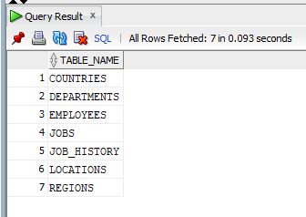

--inpect employees columns
SELECT Column_name, data_type, nullable
FROM user_tab_columns
WHERE table_name = 'EMPLOYEES'
ORDER BY column_id;
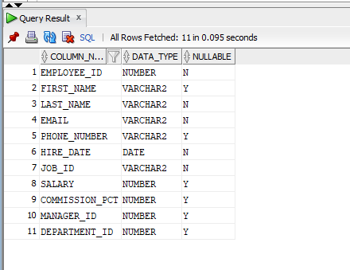

SELECT a.constraint_name,
a.table_name,
a.column_name,
c_pk.table_name AS references_table
FROM user_cons_columns a
JOIN user_constraints c ON a.constraint_name = c.constraint_name
JOIN user_constraints c_pk ON c.r_constraint_name = c_pk.constraint_name
WHERE c.constraint_type = 'R'
ORDER BY a.table_name;

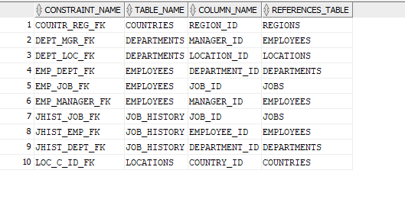
--All employees with job title
SELECT E.EMPLOYEE_ID,
E.FIRST_NAME,
E.LAST_NAME,
E.SALARY,
E.HIRE_DATE,
J.JOB_TITLE
FROM EMPLOYEES E
JOIN JOBS J ON E.JOB_ID = J.JOB_ID
ORDER BY E.EMPLOYEE_ID;
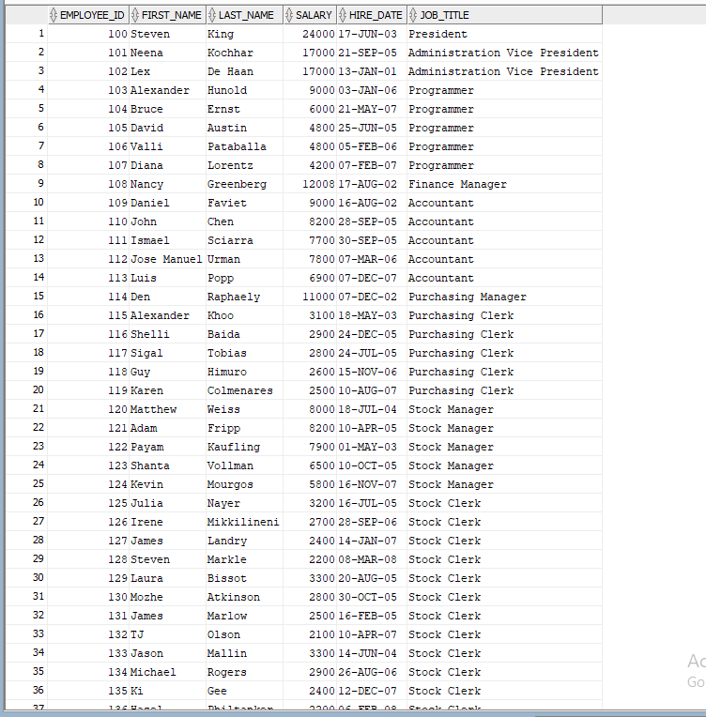

SELECT D.DEPARTMENT_ID,
D.DEPARTMENT_NAME,
L.CITY,
L.STATE_PROVINCE
FROM DEPARTMENTS D
JOIN LOCATIONS L ON D.LOCATION_ID = L.LOCATION_ID
ORDER BY D.DEPARTMENT_ID;
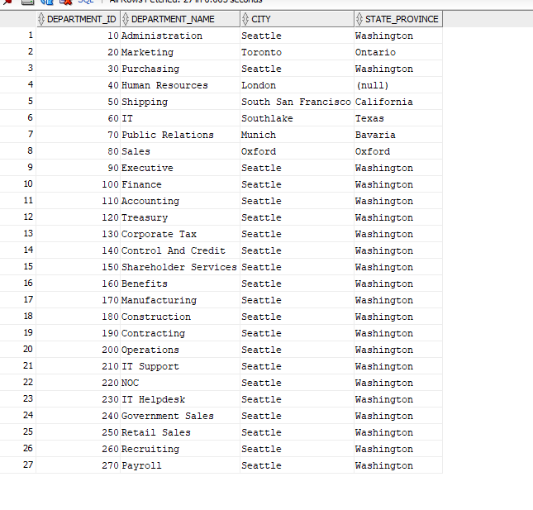
--All locations with country name
SELECT L.LOCATION_ID,
L.CITY,
L.POSTAL_CODE,
C.COUNTRY_NAME,
R.REGION_NAME
FROM LOCATIONS L
JOIN COUNTRIES C ON L.COUNTRY_ID = C.COUNTRY_ID
JOIN REGIONS R ON C.REGION_ID = R.REGION_ID
ORDER BY L.LOCATION_ID;
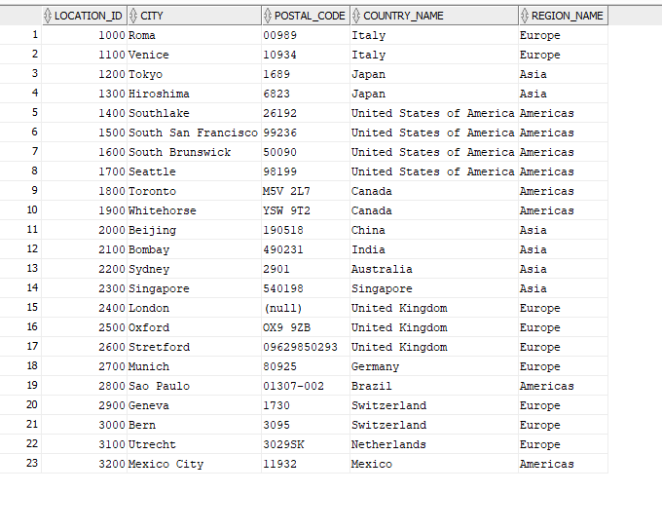

--Full employee details
-- (EMPLOYEES + DEPARTMENTS + JOBS + LOCATIONS)
SELECT E.EMPLOYEE_ID,
E.FIRST_NAME || ' ' || E.LAST_NAME AS Full_Name,
J.JOB_TITLE,
E.SALARY,
D.DEPARTMENT_NAME,
L.CITY,
C.COUNTRY_NAME
FROM EMPLOYEES E
JOIN JOBS J ON E.JOB_ID = J.JOB_ID
JOIN DEPARTMENTS D ON E.DEPARTMENT_ID = D.DEPARTMENT_ID
JOIN LOCATIONS L ON D.LOCATION_ID = L.LOCATION_ID
JOIN COUNTRIES C ON L.COUNTRY_ID = C.COUNTRY_ID
ORDER BY E.EMPLOYEE_ID;
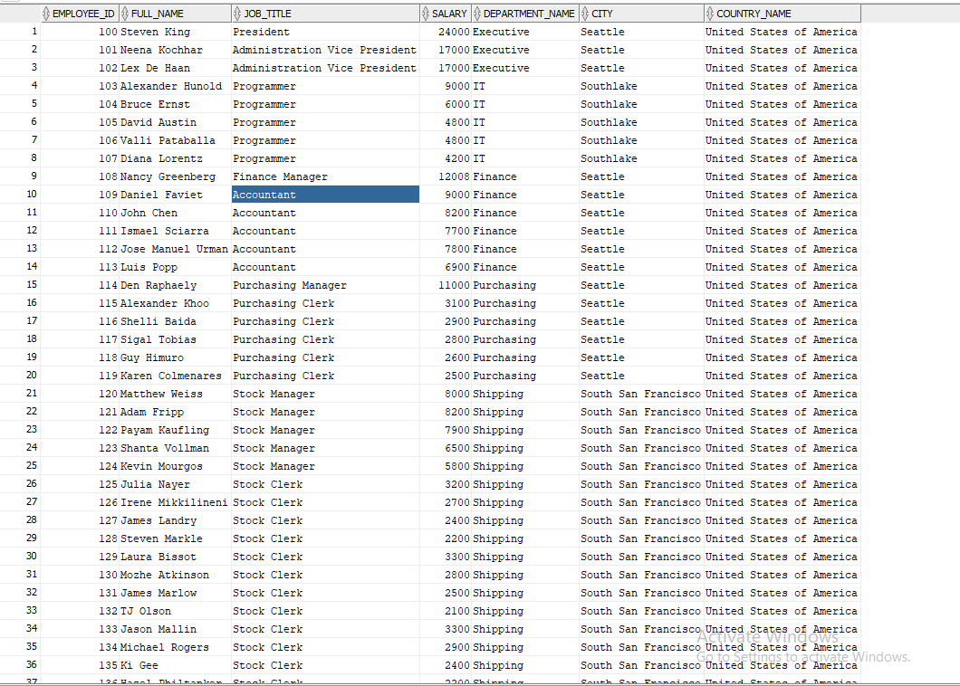

-- Employee and their manager name
SELECT E.EMPLOYEE_ID,
E.FIRST_NAME || ' ' || E.LAST_NAME AS Employee_Name,
M.FIRST_NAME || ' ' || M.LAST_NAME AS Manager_Name,
D.DEPARTMENT_NAME
FROM EMPLOYEES E
LEFT JOIN EMPLOYEES M ON E.MANAGER_ID = M.EMPLOYEE_ID
LEFT JOIN DEPARTMENTS D ON E.DEPARTMENT_ID = D.DEPARTMENT_ID
ORDER BY E.EMPLOYEE_ID;

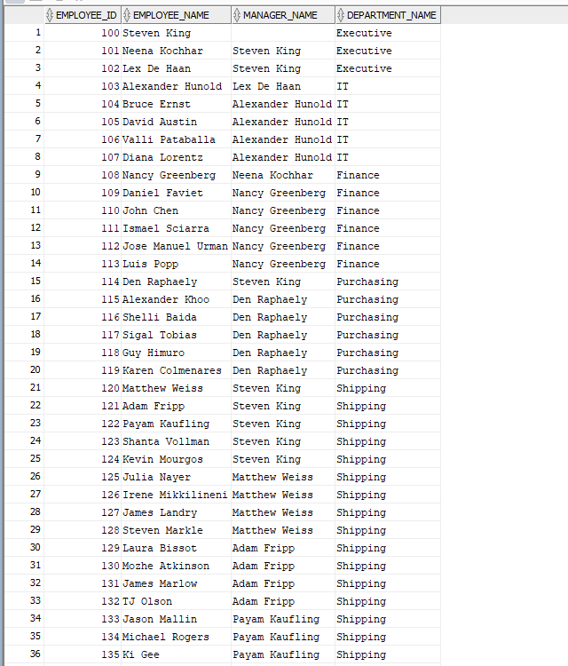

-- Departments with manager name and location
SELECT D.DEPARTMENT_ID,
D.DEPARTMENT_NAME,
E.FIRST_NAME || ' ' || E.LAST_NAME AS Manager_Name,
L.CITY,
C.COUNTRY_NAME,
R.REGION_NAME
FROM DEPARTMENTS D
LEFT JOIN EMPLOYEES E ON D.MANAGER_ID = E.EMPLOYEE_ID
LEFT JOIN LOCATIONS L ON D.LOCATION_ID = L.LOCATION_ID
LEFT JOIN COUNTRIES C ON L.COUNTRY_ID = C.COUNTRY_ID
LEFT JOIN REGIONS R ON C.REGION_ID = R.REGION_ID
ORDER BY D.DEPARTMENT_ID;
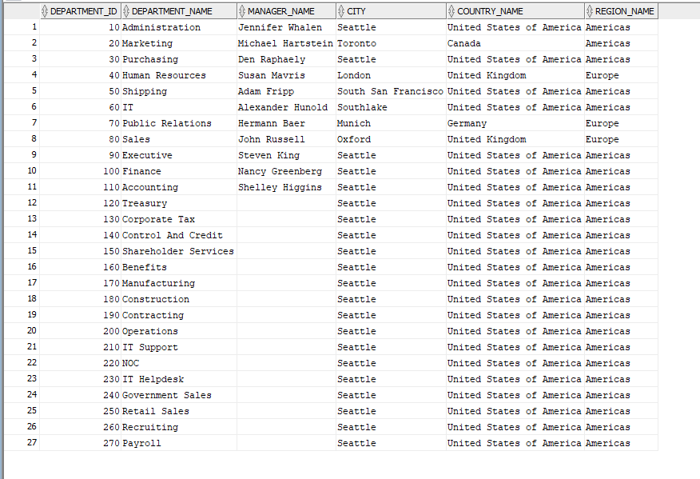

Salary summary per department
SELECT D.DEPARTMENT_NAME,
COUNT(E.EMPLOYEE_ID) AS Total_Employees,
ROUND(AVG(E.SALARY), 2) AS Avg_Salary,
SUM(E.SALARY) AS Total_Salary,
MAX(E.SALARY) AS Max_Salary,
MIN(E.SALARY) AS Min_Salary
FROM EMPLOYEES E
JOIN DEPARTMENTS D ON E.DEPARTMENT_ID = D.DEPARTMENT_ID
GROUP BY D.DEPARTMENT_NAME
ORDER BY Total_Salary DESC;
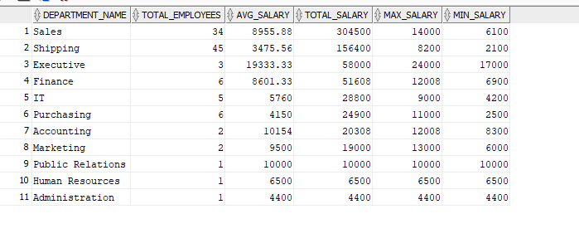
--Salary summary per job title
SELECT J.JOB_TITLE,
COUNT(E.EMPLOYEE_ID) AS Total_Employees,
ROUND(AVG(E.SALARY), 2) AS Avg_Salary,
MAX(E.SALARY) AS Max_Salary,
MIN(E.SALARY) AS Min_Salary
FROM EMPLOYEES E
JOIN JOBS J ON E.JOB_ID = J.JOB_ID
GROUP BY J.JOB_TITLE
ORDER BY Avg_Salary DESC;

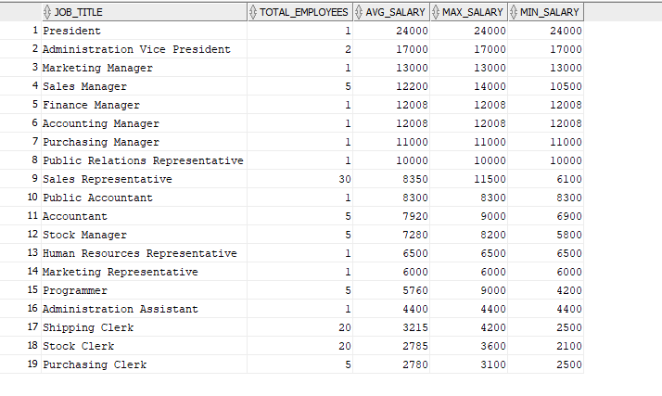

SELECT R.REGION_NAME,
COUNT(E.EMPLOYEE_ID) AS Total_Employees
FROM EMPLOYEES E
JOIN DEPARTMENTS D ON E.DEPARTMENT_ID = D.DEPARTMENT_ID
JOIN LOCATIONS L ON D.LOCATION_ID = L.LOCATION_ID
JOIN COUNTRIES C ON L.COUNTRY_ID = C.COUNTRY_ID
JOIN REGIONS R ON C.REGION_ID = R.REGION_ID
GROUP BY R.REGION_NAME
ORDER BY Total_Employees DESC;

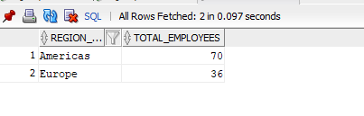
-- Departments with more than 5 employees
SELECT D.DEPARTMENT_NAME,
COUNT(E.EMPLOYEE_ID) AS Total_Employees,
ROUND(AVG(E.SALARY), 2) AS Avg_Salary
FROM EMPLOYEES E
JOIN DEPARTMENTS D ON E.DEPARTMENT_ID = D.DEPARTMENT_ID
GROUP BY D.DEPARTMENT_NAME
HAVING COUNT(E.EMPLOYEE_ID) > 5
ORDER BY Total_Employees DESC;
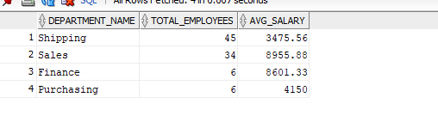
--High paying jobs (avg salary above 10000)
SELECT J.JOB_TITLE,
ROUND(AVG(E.SALARY), 2) AS Avg_Salary,
COUNT(E.EMPLOYEE_ID) AS Total_Employees
FROM EMPLOYEES E
JOIN JOBS J ON E.JOB_ID = J.JOB_ID
GROUP BY J.JOB_TITLE
HAVING AVG(E.SALARY) > 10000
ORDER BY Avg_Salary DESC;
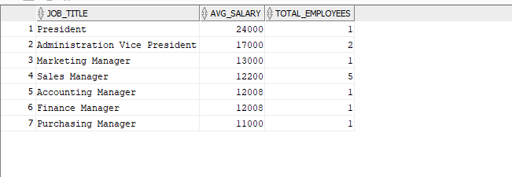

-- Top 5 highest paid employees
SELECT E.FIRST_NAME || ' ' || E.LAST_NAME AS Employee_Name,
J.JOB_TITLE,
D.DEPARTMENT_NAME,
E.SALARY
FROM EMPLOYEES E
JOIN JOBS J ON E.JOB_ID = J.JOB_ID
JOIN DEPARTMENTS D ON E.DEPARTMENT_ID = D.DEPARTMENT_ID
ORDER BY E.SALARY DESC
FETCH FIRST 5 ROWS ONLY;

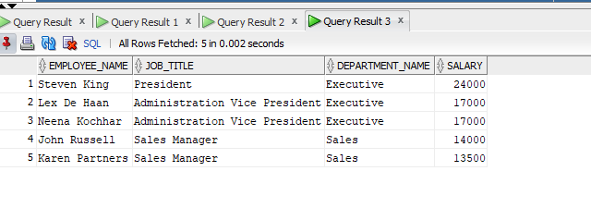
-- Employees earning above average salary
SELECT E.FIRST_NAME || ' ' || E.LAST_NAME AS Employee_Name,
E.SALARY,
J.JOB_TITLE,
D.DEPARTMENT_NAME
FROM EMPLOYEES E
JOIN JOBS J ON E.JOB_ID = J.JOB_ID
JOIN DEPARTMENTS D ON E.DEPARTMENT_ID = D.DEPARTMENT_ID
WHERE E.SALARY > (SELECT AVG(SALARY) FROM EMPLOYEES)
ORDER BY E.SALARY DESC;

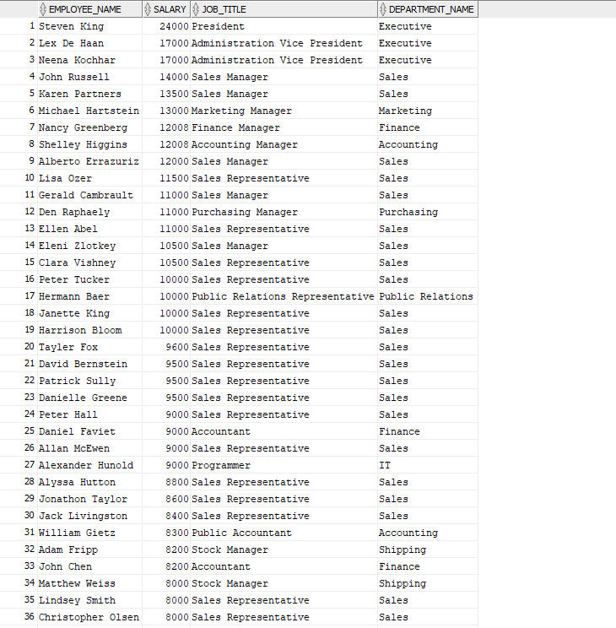

--Years of service per employee
SELECT E.FIRST_NAME || ' ' || E.LAST_NAME AS Employee_Name,
E.HIRE_DATE,
TRUNC(MONTHS_BETWEEN(SYSDATE,
E.HIRE_DATE) / 12) AS Years_of_Service,
D.DEPARTMENT_NAME
FROM EMPLOYEES E
JOIN DEPARTMENTS D ON E.DEPARTMENT_ID = D.DEPARTMENT_ID
ORDER BY Years_of_Service DESC;
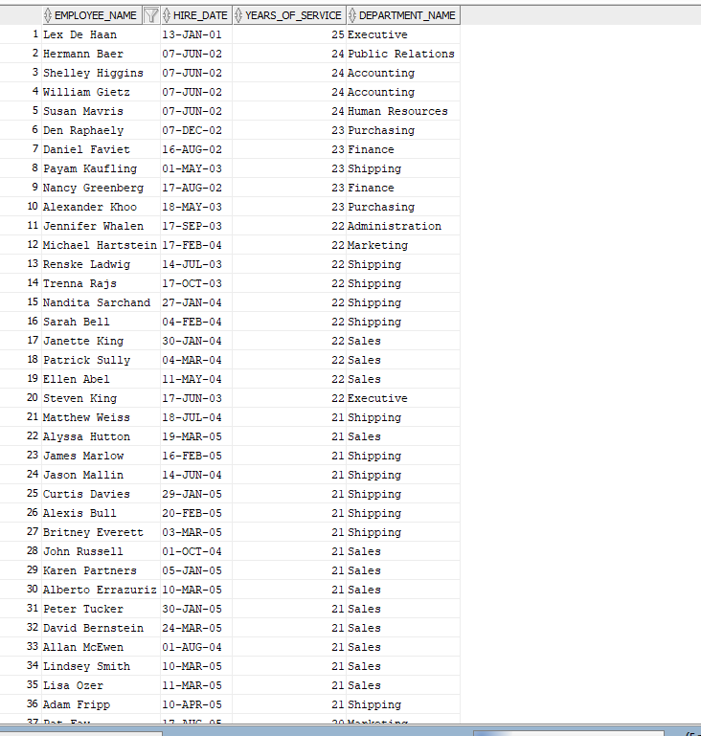

2. Employee & Department Reports
--Employee ID, Full Name, Department Name
SELECT E.EMPLOYEE_ID,
E.FIRST_NAME || ' ' || E.LAST_NAME AS Full_Name,
D.DEPARTMENT_NAME
FROM EMPLOYEES E
JOIN DEPARTMENTS D ON E.DEPARTMENT_ID = D.DEPARTMENT_ID
ORDER BY E.EMPLOYEE_ID;
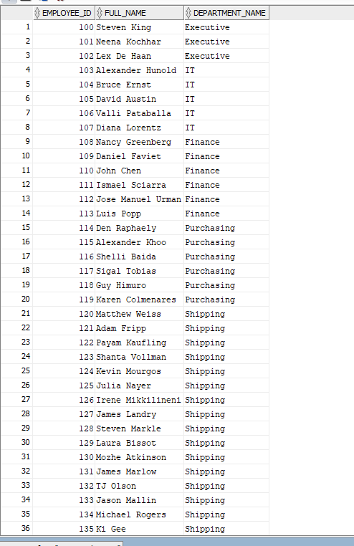

-- Employee Full Name, Job Title, Salary
SELECT E.FIRST_NAME || ' ' || E.LAST_NAME AS Full_Name,
J.JOB_TITLE,
E.SALARY
FROM EMPLOYEES E
JOIN JOBS J ON E.JOB_ID = J.JOB_ID
ORDER BY E.SALARY DESC;
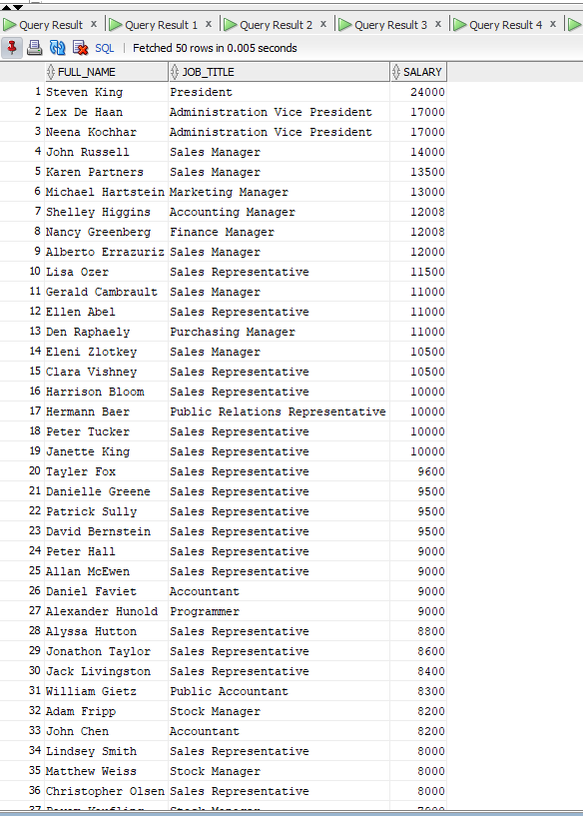

-Employee, Department, Department City
SELECT E.FIRST_NAME || ' ' || E.LAST_NAME AS Full_Name,
D.DEPARTMENT_NAME,
L.CITY AS Department_City
FROM EMPLOYEES E
JOIN DEPARTMENTS D ON E.DEPARTMENT_ID = D.DEPARTMENT_ID
JOIN LOCATIONS L ON D.LOCATION_ID = L.LOCATION_ID
ORDER BY D.DEPARTMENT_NAME;
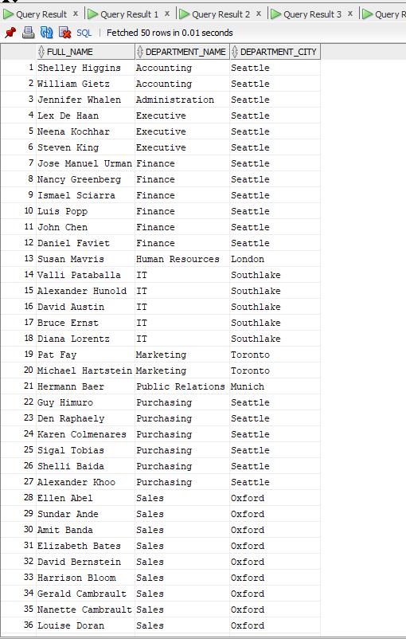

--Employee, Department, Country, Region
SELECT E.FIRST_NAME || ' ' || E.LAST_NAME AS Full_Name,
D.DEPARTMENT_NAME,
C.COUNTRY_NAME,
R.REGION_NAME
FROM EMPLOYEES E
JOIN DEPARTMENTS D ON E.DEPARTMENT_ID = D.DEPARTMENT_ID
JOIN LOCATIONS L ON D.LOCATION_ID = L.LOCATION_ID
JOIN COUNTRIES C ON L.COUNTRY_ID = C.COUNTRY_ID
JOIN REGIONS R ON C.REGION_ID = R.REGION_ID
ORDER BY R.REGION_NAME, C.COUNTRY_NAME;
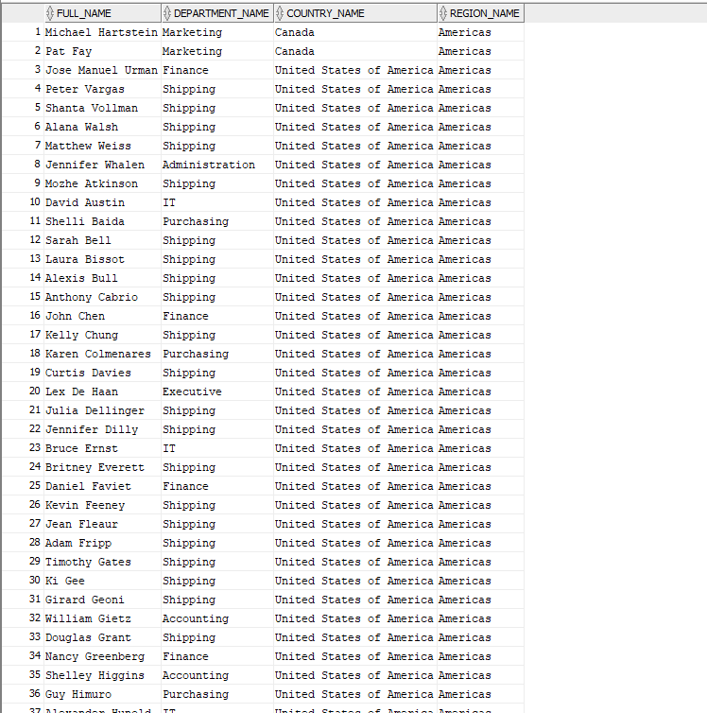

3. Organization Structure Analysis
--Complete employee list
--INCLUDING employees WITHOUT departments
SELECT E.EMPLOYEE_ID,
E.FIRST_NAME || ' ' || E.LAST_NAME AS Full_Name,
E.JOB_ID,
E.SALARY,
NVL(D.DEPARTMENT_NAME, 'No Department Assigned') AS Department_Name
FROM EMPLOYEES E
LEFT JOIN DEPARTMENTS D ON E.DEPARTMENT_ID = D.DEPARTMENT_ID
ORDER BY E.EMPLOYEE_ID

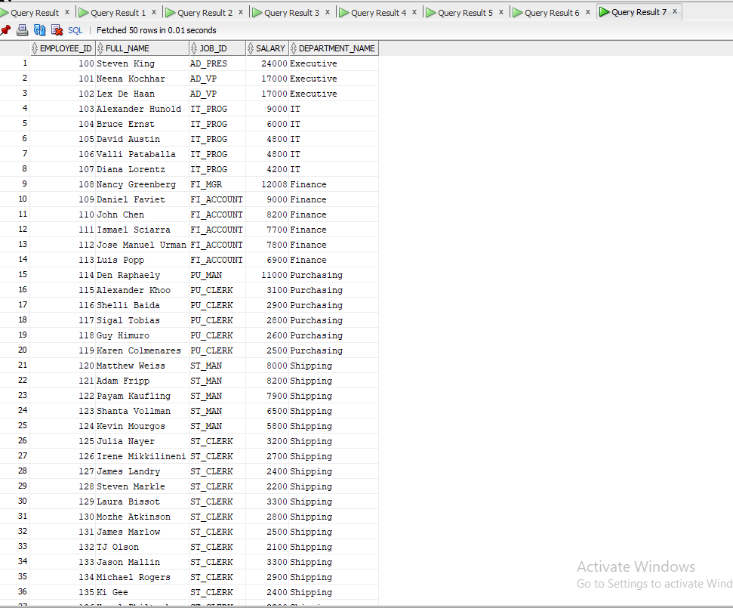
-- Complete department list
SELECT D.DEPARTMENT_ID,
D.DEPARTMENT_NAME,
COUNT(E.EMPLOYEE_ID) AS Total_Employees,
NVL(TO_CHAR(COUNT(E.EMPLOYEE_ID)),
'No Employees') AS Employee_Count
FROM EMPLOYEES E
RIGHT JOIN DEPARTMENTS D ON E.DEPARTMENT_ID = D.DEPARTMENT_ID
GROUP BY D.DEPARTMENT_ID, D.DEPARTMENT_NAME
ORDER BY D.DEPARTMENT_ID;
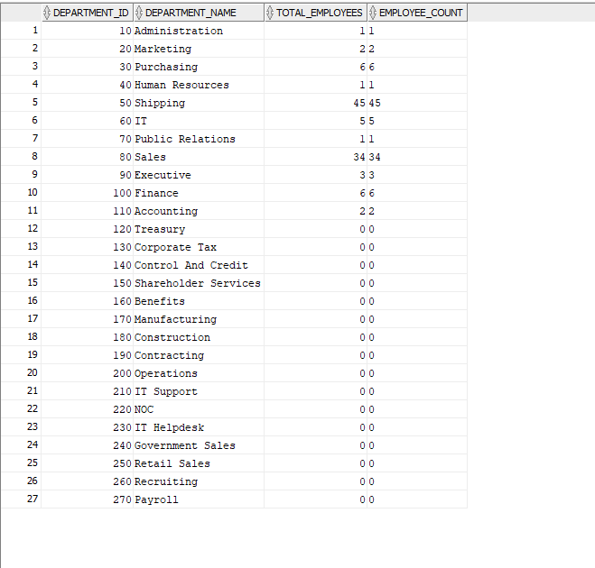

-- Departments that currently have NO employees assigned
SELECT D.DEPARTMENT_ID,
D.DEPARTMENT_NAME,
L.CITY AS Location
FROM DEPARTMENTS D
LEFT JOIN EMPLOYEES E ON D.DEPARTMENT_ID = E.DEPARTMENT_ID
LEFT JOIN LOCATIONS L ON D.LOCATION_ID = L.LOCATION_ID
WHERE E.EMPLOYEE_ID IS NULL
ORDER BY D.DEPARTMENT_ID;
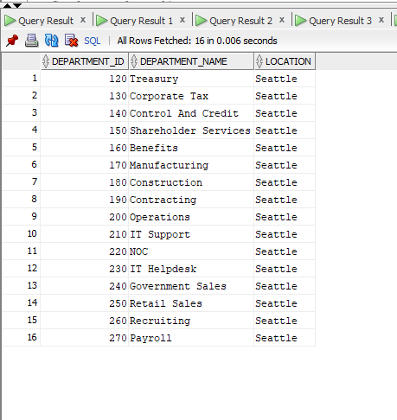

4. Management Hierarchy Analysis
-- Employee name and direct manager name
SELECT E.EMPLOYEE_ID,
E.FIRST_NAME || ' ' || E.LAST_NAME AS Employee_Name,
E.JOB_ID AS Employee_Job,
E.SALARY AS Employee_Salary,
M.EMPLOYEE_ID AS Manager_ID,
M.FIRST_NAME || ' ' || M.LAST_NAME AS Manager_Name,
M.JOB_ID AS Manager_Job
FROM EMPLOYEES E
JOIN EMPLOYEES M ON E.MANAGER_ID = M.EMPLOYEE_ID
ORDER BY M.EMPLOYEE_ID, E.EMPLOYEE_ID;

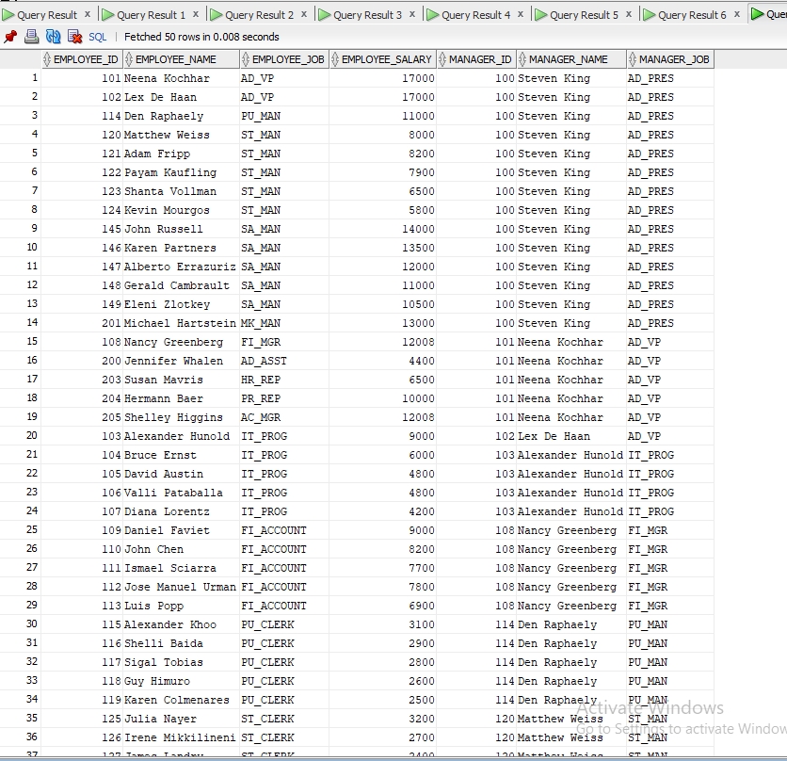

-- Employees WITHOUT managers
SELECT E.EMPLOYEE_ID,
E.FIRST_NAME || ' ' || E.LAST_NAME AS Employee_Name,
E.JOB_ID,
E.SALARY,
E.DEPARTMENT_ID,
NVL(TO_CHAR(E.MANAGER_ID),
'No Manager - Top Level') AS Manager_Status
FROM EMPLOYEES E
WHERE E.MANAGER_ID IS NULL
ORDER BY E.EMPLOYEE_ID;
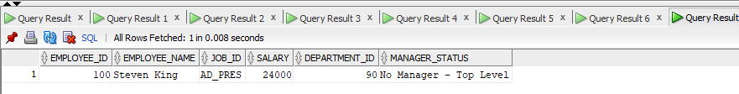

5. Advanced Business Analysis

--Employees earning MORE than
-- their direct manager
SELECT E.EMPLOYEE_ID,
E.FIRST_NAME || ' ' || E.LAST_NAME AS Employee_Name,
E.JOB_ID AS Employee_Job,
E.SALARY AS Employee_Salary,
M.FIRST_NAME || ' ' || M.LAST_NAME AS Manager_Name,
M.JOB_ID AS Manager_Job,
M.SALARY AS Manager_Salary,
E.SALARY - M.SALARY AS Salary_Difference
FROM EMPLOYEES E
JOIN EMPLOYEES M ON E.MANAGER_ID = M.EMPLOYEE_ID
WHERE E.SALARY > M.SALARY
ORDER BY Salary_Difference DESC;
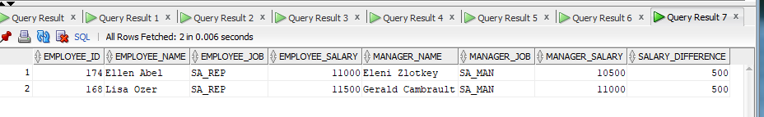

-- Departments where the manager -works WITHIN the same department
SELECT D.DEPARTMENT_ID,
D.DEPARTMENT_NAME,
E.EMPLOYEE_ID AS Manager_ID,
E.FIRST_NAME || ' ' || E.LAST_NAME AS Manager_Name,
E.JOB_ID AS Manager_Job,
E.SALARY AS Manager_Salary,
L.CITY AS Department_City
FROM DEPARTMENTS D
JOIN EMPLOYEES E ON D.MANAGER_ID = E.EMPLOYEE_ID
AND D.DEPARTMENT_ID = E.DEPARTMENT_ID
JOIN LOCATIONS L ON D.LOCATION_ID = L.LOCATION_ID
ORDER BY D.DEPARTMENT_ID;

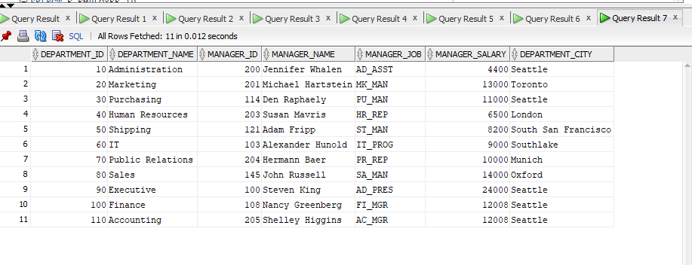

6.

